Brain Building Bingo
Jonathan’s Dream

Name: _________________________________________

Explore a Braille book from the little library- Be sure to return it for other friends to enjoy! | Read a book with a friend at Jonathan’s Dream. Take a picture and share it using #Jonathan’s  DreamBingo | Create a new title for your book! | Use Jonathan’s Dream chalkboard station to draw the characters from your book
Read a book out loud in front of the mirrors in the park-or one at home-using a lot of expression | Use the “Let’s Talk About Nature” board found in the park to talk about the great outdoors | Write your own short story about your trip to Jonathan’s Dream | Learn 5 new words this summer through the books you read or other forms of exploration
Find a perfect spot in the treehouse at Jonathan’s Dream and read | Read a book with your family before bed | Take turns reading pages of a book with a friend in the large glider swing | Read a book about a different country
Read a book with a friend- then create the sequel out loud! | Read a poem and create one yourself- Write it down or share it out loud to a friend or family member | Read a book about a sport or activity that interests you- then visit Jonathan’s Dream basketball hoops or yoga pose station! | Recommend a book to a friend and have them recommend a book to you!
Create and practice a song using the many sound makers throughout the park | Read a non-fiction book | Use this FREE space to collect your prize! | Practice spelling your name in sign language using Jonathan’s Dream Sign Language board to help you
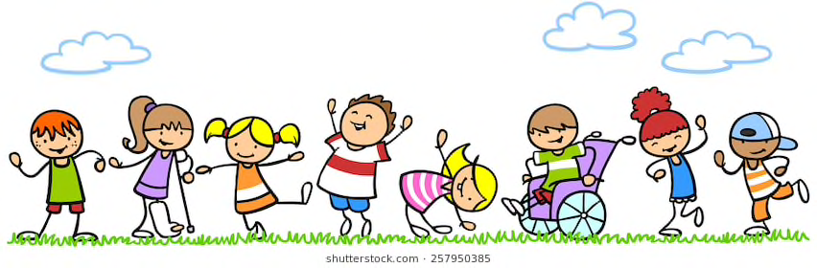
Visit us at:
www.jonathansdream.org
Jonathan’s Dream

